Name: Aspeta Divakar

Trainer Name: Harshee Pitroda

Course Name: Python & Machine Learning

Date:03/06/2022

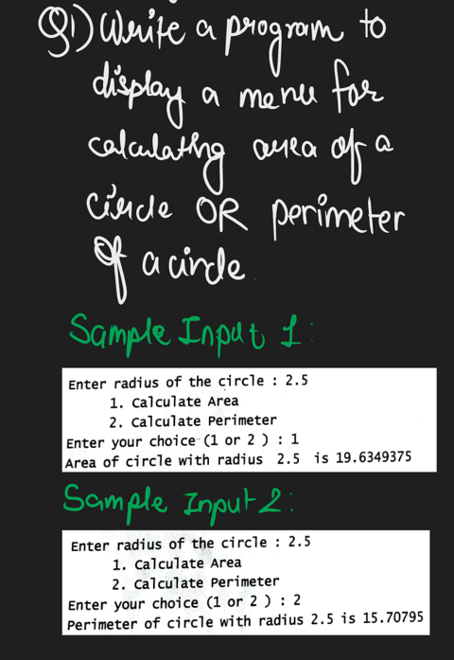

Code:

a=float(input('Enter radius of circle:'))

print('1.Calculate Area')

print('2.Calculate Perimeter')

b=int(input('Enter your choice(1 or 2):'))

if b==1:

Area=3.14\*a\*\*2

print('Area of circle with radius {} is {}'.format(a,Area))

if b==2:

perimeter=2\*3.14\*a

print('perimeter of circle with radius {} is {}'.format(a,perimeter))

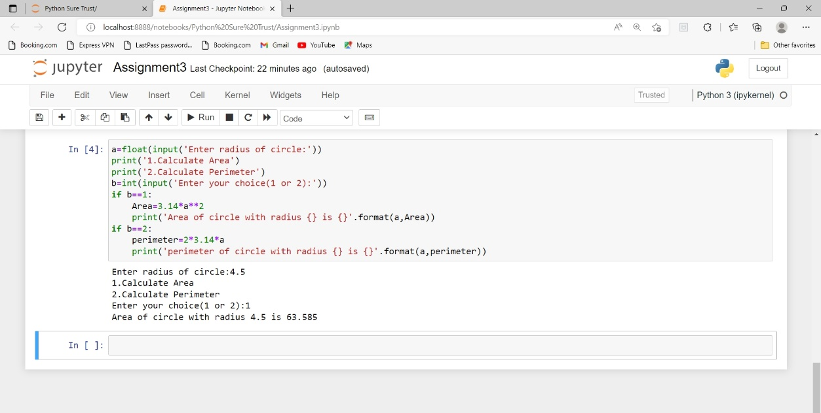

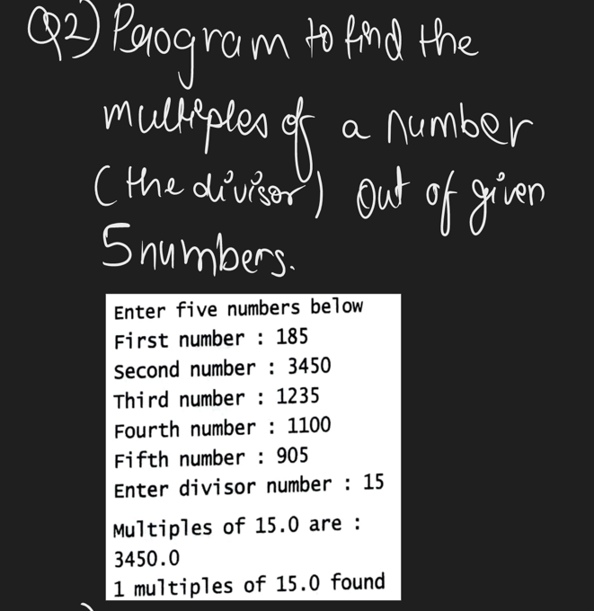

Code:

a=int(input('First number:'))

b=int(input('Second number:'))

c=int(input('Third number:'))

d=int(input('Fourth number:'))

e=int(input('Fifth number:'))

f=int(input('Enter divisor number:'))

count=0

print('Multiples of {} are:'.format(f))

Reminder1=a%f

if Reminder1==0:

count+=1

print(a)

Reminder2=b%f

if Reminder2==0:

count+=1

print(b)

Reminder3=c%f

if Reminder3==0:

count+=1

print(c)

Reminder4=d%f

if Reminder4==0:

count+=1

print(d)

Reminder5=e%f

if Reminder5==0:

count+=1

print(e)

print('{} multiples of {} found'.format(count,f))

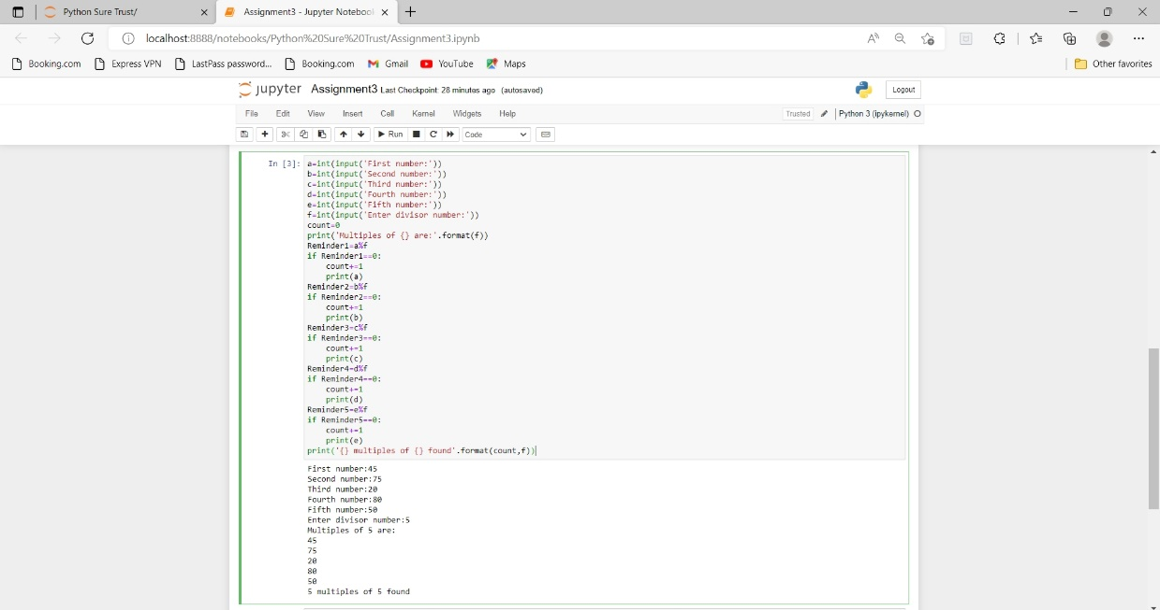

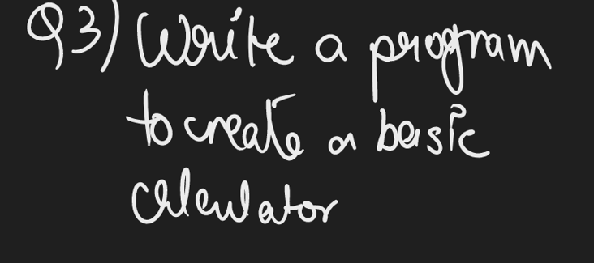

Code:

num=int(input('Enter your choice:'))

import math

if num==1:

a=int(input('Enter first number:'))

b=int(input('Enter second number:'))

sum=a+b

print('sum is',sum)

elif num==2:

a=int(input('Enter first number:'))

b=int(input('Enter second number:'))

sub=a-b

print('subtration is',sub)

elif num==3:

a=int(input('Enter first number:'))

b=int(input('Enter second number:'))

mul=a\*b

print('Multiplication is',mul)

elif num==4:

a=int(input('Enter first number:'))

b=int(input('Enter second number:'))

divi=a/b

print('Division is',divi)

elif num==5:

a=int(input('Enter first number:'))

b=int(input('Enter second number:'))

pow=a\*\*b

print('Power is',pow)

elif num==6:

a=int(input('Enter first number:'))

b=int(input('Enter second number:'))

mod=a%b

print('Modulus is',mod)

elif num==7:

a=int(input('Enter first number:'))

b=int(input('Enter second number:'))

floor=a//b

print('Floor is',floor)

elif num==8:

a=int(input('Enter a value:'))

print('The log value for {} is {}'.format(a,math.log(a)))

elif num==9:

a=int(input('Enter a value:'))

print('The sin value for {} is {}'.format(a,math.sin(a)))

elif num==10:

a=int(input('Enter a value:'))

print('The tan value for {} is {}'.format(a,math.tan(a)))

else:

print('select the operation from the above')

